Prediabetes Social Copy 2018

Social Copy for Partner Posts
Post Description | Copy | Characters
Supporter Video Share Post 1 | 1 in 3 American adults has prediabetes. Learn about your #prediabetes risk with new PSAs from @AdCouncil @CDCDiabetes @AmerMedicalAssn | 135
Supporter Video Share Post 2 | This #WorldDiabetesDay, know where you stand by taking the 1-minute prediabetes risk test at DoIHavePrediabetes.org. | 116
Sponsor Launch Post 1 | 1 in 3 American adults has prediabetes, but 90% of them don't know they have it. Find out where you stand at DoIHavePrediabetes.org. | 132
Sponsor Launch Post 2 | 1 in 3 American adults has prediabetes. That could be you, your boss, or your boss's boss. Learn your risk at DoIHavePrediabetes.org. | 133
Sponsor Launch Post 3 | 1 in 3 American adults has prediabetes, so chances are you or someone you know may be at risk. Find out where you stand at DoIHavePrediabetes.org. | 146
Sponsor Launch Post 4 | Whether it's you, your favorite brother or your…other brother, someone you know likely has prediabetes. The good news is that with early diagnosis, prediabetes can be reversed. | 176
Sponsor Launch Post 5 | There's no better time than #WorldDiabetesDay to find out your prediabetes risk. Take the 1-minute risk test at DoIHavePrediabetes.org. | 135
Sponsor Launch Post 5 | There's no better time than November - National Diabetes Month - to find out if you may be among the 1 in 3 American adults with prediabetes. Take the 1-minute risk test at DoIHavePrediabetes.org. | 196

English Copy for Social Graphics
Creative
Graphics | Copy
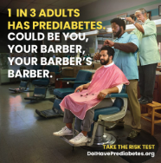  Barber | FB: It's better to know than wonder. Take this risk test in one minute, to find out if you're one of the 1 in 3 American adults with prediabetes. Visit www.DoIHavePrediabetes.org/take-the-risk-test
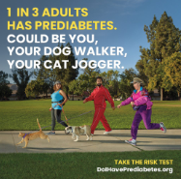  Cat Jogger | FB: It's better to know than wonder. Take this risk test in one minute, to find out if you're one of the 1 in 3 American adults with prediabetes. Visit www.DoIHavePrediabetes.org/take-the-risk-test

Statistics
Graphics | Copy
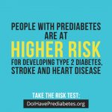  Higher Risk | FB: Reversing prediabetes will lower your risk for significant health complications like heart disease and stroke. Visit DoIHavePrediabetes.org to learn more.  Twitter: #Prediabetes increases risk for heart disease and stroke. But taking action will decrease your risk. Learn more at DoIHavePrediabetes.org.
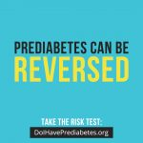  Reversed | FB: It’s not too late. Fortunately, prediabetes can be reversed. To maintain a healthy future, take a minute to visit DoIHavePrediabetes.org and learn more.  Twitter: It's not too late to act because #prediabetes can often be reversed. Visit DoIHavePrediabetes.org to learn more.
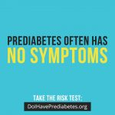  No Symptoms | FB: #Prediabetes often has no symptoms, but it's important to know where you stand. Visit DoIHavePrediabetes.org to find out if you're at risk.  Twitter: #Prediabetes often has no symptoms, but it's important to know where you stand. Visit DoIHavePrediabetes.org to find out if you're at risk.

Lifestyle
Graphics | Copy
Move More Each Day | FB: Finding time to stay active every day can help reverse prediabetes. Take a one-minute risk test at DoIHavePrediabetes.org to find out where you stand.  Staying active every day can help reverse #prediabetes. Find out if you're at risk at DoIHavePrediabetes.org.
Get Moving | FB: Find the exercise routine that works for you...and have fun with it! Simple lifestyle changes like adding exercise to your busy schedule can help reverse prediabetes. To learn where you stand with prediabetes, visit DoIHavePrediabetes.org.  Twitter: Exercise can be fun when you're making lifestyle changes to reverse #prediabetes. Learn if you're at risk at DoIHavePrediabetes.org.
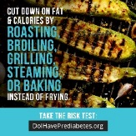  Cut Down | FB: Eating healthier can help reverse prediabetes, but you don't have to sacrifice flavor while you're cutting down on fat and calories. Find out if you're at risk for prediabetes by heading to DoIHavePrediabetes.org.  Twitter: Cutting calories doesn't mean cutting flavor if you have #prediabetes. Find out if you're at risk at DoIHavePrediabetes.org.
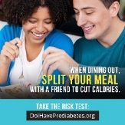  When Dining Out | FB: Dining out isn't off the table if you have prediabetes. You can enjoy your favorite restaurants by managing your calories. Take a minute to visit DoIHavePrediabetes.org and find out if you're at risk.  Twitter: Dining out isn't off the table if you have #prediabetes. Make healthy choices to manage calories. Learn your risk at DoIHavePrediabetes.org.
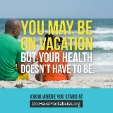  Vacation | FB: 1 in 3 Americans are at risk for significant health complications like type 2 diabetes, heart disease and stroke. Visit DoIHavePrediabetes.org to learn your risk.  Twitter: 1 in 3 Americans are at risk for significant health complications like type 2 diabetes, heart disease and stroke. Learn your risk at DoIHavePrediabetes.org.

Spanish Copy for Social Graphics

Creative
Graphics | Copy
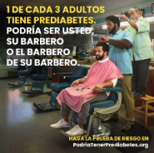  Barbero | FB: Nadie está exento de la prediabetes, tome una pequeña prueba en línea en PodriaTenerPrediabetes.org para saber si usted tiene prediabetes
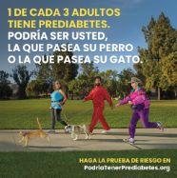  La Que Pasea Su Gato | FB: Nadie está exento de la prediabetes, tome una pequeña prueba en línea en PodriaTenerPrediabetes.org para saber si usted tiene prediabetes

Statistics
Graphics | Copy
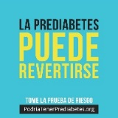  La Prediabetes Puede Revertirse | FB: Más de 1 de cada 3 estadounidenses tienen prediabetes. Pero con un poco de ejercicio y un cambio en su dieta, se puede revertir. Tome una pequeña prueba en línea visitando PodriaTenerPrediabetes.org para ver si usted puede estar en riesgo.  Twitter: ¿Sabía usted que 84 millones de estadounidenses tienen prediabetes? Pero se puede revertir. Visite PodriaTenerPrediabetes.org.
En Riesgo | FB: Nadie está exento de la prediabetes, tome una pequeña prueba en línea en PodriaTenerPrediabetes.org para saber si usted tiene prediabetes

Lifestyle
Graphics | Copy
No Vacaciones | FB: 1 de cada 3 estadounidenses tienen un mayor riesgo de desarrollar problemas de salud graves como la diabetes tipo 2, accidentes cerebrovasculares y cardíacas. Tome una pequeña prueba en línea visitando PodriaTenerPrediabetes.org para ver si usted puede estar en riesgo.  Twitter: Toma menos de un minuto saber si usted tiene #prediabetes. Visite PodriaTenerPrediabetes.org para saber en qué nivel está.

